AZ 203 Azure Developer - Part 1

07 March 2020

11:56

------------Covering AZ 203 Certification---------- Scott Duffy Course.

* ksaz203
* Yamahalibero123$

* For development for azure, install azure SDK which comes for a variety platforms.

Machine generated alternative text:
Azure SDK 
Install the Azure SDK for an additional set of templates and tools that help you access even more cloud resources and services to improve your Azure development experience 
directly from Visual Studio. use th&e tools to deploy infinitely-scalable applications and APIs, configure diagnostics, create and manage app service resources, and integrate your 
data. 
.NET SDK 
Java SDK 
Node SDK 
Python SDK 
Ruby SDK 
SDK 
Xamarin 
Android 
iOS 
Windows 
V'sual Studio 2019 > 
Visual Studio 2017 
NuGet packages > 
Source on GitHub > 
Documentation > 
Sanvles > 
Previous versions > 

Azure SDKs now come as unified SDKs and there are many packages for various azure services. They make using Azure Services easier and internally call Azure REST APIs to handle various operations.

Unified SDKs screen sample (For Windows and Visual Studio)

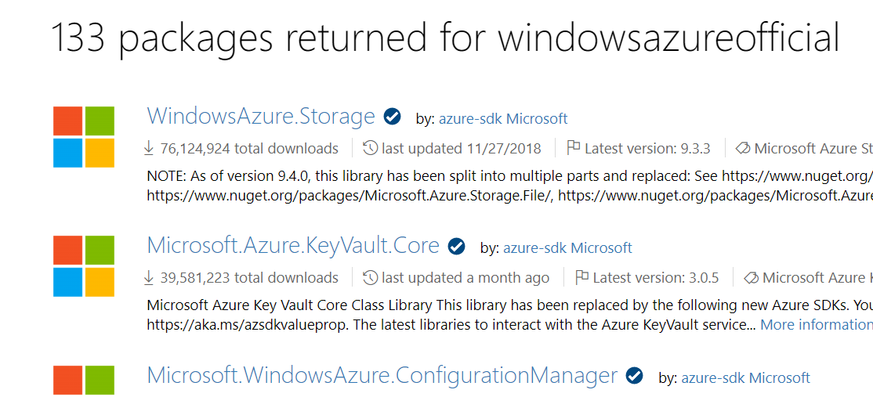

* Install PST and Command Line Tools.

Machine generated alternative text:
Command-line tools 
Manage your Azure services and apps using scripts from the command line. 
Azure command-line 
interface 
Install 
Documentation 
Azure Storage Emulator 
Install 
Documentation 
PowerShell 
Install 
Documentation 
AzCopy Command-Line 
Tool for Azure Storage 
Install (Windows only) 
Install (cross-platform) 
Documentation 
Documentation (if using AzCopy 
VIC)) 

Azure Cli - Using MSI or

Invoke-WebRequest -Uri <https://aka.ms/installazurecliwindows> -OutFile .\AzureCLI.msi; Start-Process msiexec.exe -Wait -ArgumentList '/I AzureCLI.msi /quiet' - cmd may change ..

* Azure PST - on PST 5.1/PST Core Using MSI or

Install-Module -Name Az -AllowClobber -Scope AllUsers

* Azure Storage Emulator- Using MSI

* AzCopy for managing Sotrage accounts - cmd line - either cross platform from github OR windows based using an MSI.

And some Tools

* Azure Storage Explorer - comes for each platform.

**Azure Data Studio** is a free Microsoft desktop tool, initially called SQL Operations **Studio**, that can be used to manage SQL Server databases and cloud-based **Azure** SQL **Database** and **Azure** SQL **Data** Warehouse systems- available as MSI

Azure CloudShell - to run commands in browser - it needs storage account & subscription details to launch.

We can even run PST or CLI commands using Cloud Shell provided in Azure Portal itself.

IMP - for self subscriptions - its imp to keep track of pricing of all resources and services. Azure Pricing Calculator is tool for that.

<https://azure.microsoft.com/en-in/pricing/calculator>

Pricing depends on actual Resource + Its usage like transactions / IOPS / ingress-egress traffic etc.

IMP - Some Resources -

* to see code on Azure we have Azure Samples repo in GitHub - <https://github.com/Azure-Samples?q=&type=&language=c%23>
* <https://azurecitadel.com/> - there are hands on labs and is an official Microsoft site as well.

<https://azurecitadel.github.io/labs/>

* <https://www.microsoft.com/handsonlabs> - also available. Here we get auto generated ID/Psw to connect to portal and don’t need own subscription. Based on Role category there are different set of labs but it may or may not provide all services to be tested.
* Microsoft.com/Learn - based on role there are different learning contents with lot of reading.
* <https://azure.microsoft.com/en-us/resources/samples/?sort=0>

* IMP - Microsoft official AZ 203 Labs

<https://microsoftlearning.github.io/AZ-203-DevelopingSolutionsforMicrosoftAzure/>

VMs -

* Are charged for usage + storage attached to them. So even if stopped/deallocated storage will still be charged. Deleting delete it completely.
* There are 50+ regions across globe but some of them are restricted like China regions may not be allowed OR some Defense regions etc.
* Instances/Services availability may vary with regions.
* VM Images
  + Windows/linux/ubuntu based.
  + Can create our own images and upload and then use it to deploy a VM using PST/CLI.
  + Not possible to have an image without OS.
* Some things can be done with command line better than Portal and some may only be done using PST/cmd line.
* VM Sizes - ones with 'S' mostly means SSD storage based. It also states number of data disks possible.
* In most subscriptions/accounts, VCPUs have default limits ie 10 VCPUs max but we can ask MS to enable high CPU sizes as well which will be very expensive.
* IOPS - operations per sec.
* Default inbound Traffic - by default all inbound traffic is disabled including RDP/Http ports etc. (this default may change and need to be checked). We can enable it based on req. RDP over internet isnt a good design and should be managed from within company network which means only using private IPs and Ports/jump servers etc.

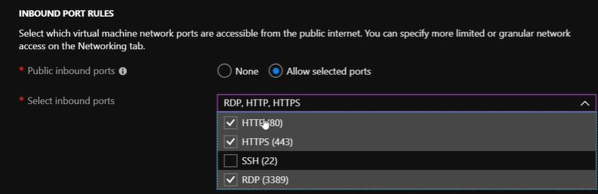

1. There is an option of accelerated networking in VM network configuration - need to check.

* VM - Management
* There is an option of auto-shutdown. Good to automate and reduce cost.
* Can download ARM template for VM entire configuration - for automation.
* Machine == VM + NIC + IP + NSG + RG + VNET + Disks + Storage Account - better control. Deleting VM wont delete IP/RG etc.
* Under IP Address configuration - we can do OP to Domain name mapping with globally unique name with default Azure DNS server.
* For http/https port to work, we need to install web server role on the VM first.
* IMP - if RDP doesn’t work
  + VM running state.
  + Check NSGs for inbound traffic on VNET/Subnet/NIC card and also Firewall settings in VM itself if port 3389 is enabled for inbound or not.
  + If all well and still not working- Restart VM or may be re-create VM if nothing works.

* VMs may use dedicated hosts in azure DCs

Host

Azure Dedicated Hosts allow you to provision and manage a physical server within our data centers that are dedicated to your Azure subscription. A dedicated host gives you assurance that only VMs from your subscription are on the host, flexibility to choose VMs from your subscription that will be provisioned on the host, and the control of platform maintenance at the level of the host.

* Proximity placement group

Proximity placement groups allow you to group Azure resources physically closer together in the same region.

* ARM templates - when downloaded now don’t include C#/PST/CLI etc and it's just ARM template and Parameter file. Commands to deploy ARM can be seen online OR use below link

<https://github.com/gottagetgit/ARMDeploy>

Contains C#/Ruby/PST based deployment files.

Templates can be stored in Template Library as well in the microsoft account used.

Machine generated alternative text:
Dashboard > New ) Create a virtual machine > 
Template 
Add to library Deploy 
Download 
Automate deploying resources with Azure Resource Manager tem 
about template deployment. 
Template 
CLI power-Shell .NET Ruby 
parameters 

* VM Encryption - is OS disks and Data disks can be encrypted. All Files in Azure storage account are by default encrypted using Secured Storage Encryption. But once we are able to see the Disks/VHDs in the storage account they aren't encrypted with their content.
  + Can use Bit Locker for this and cryptographic key should be in key-vault service.
  + Create key-vault first - used to store Cryptographic keys or Application Secrets or Security Certificates. Key-Vault should be in same region as VM region in order to perform encryption.
  + Add key

Machine generated alternative text:
Microsoft Azure 
(0 
o 
Dashboard azsjdkepault- Keys 
Create a key 
Create a key 
Optio 
Key 
RSA 
4096 
Set activation 
Sot expiration date? O 

* We can use PST in Cloud Shell or locally for enabling Disk Encryption.

Script for encryption can be found in MS docs

Machine generated alternative text:
aul " -ResourceGroupName 
2 
3 
4 
5 
6 
7 
8 
9 
10 
11 
12 
13 
14 
$keyVau1t Get-AzureRmKeyVau1t -vaultName 
$diskEncryptionKeyVau1tUr1 = $keyVau1t. VaultUri; 
$keyVau1tResourceId = $keyVau1t.ResourceId; 
-Name 
" azkeywault" ; 
" azsjddiskencryption") . Key. kid; 
$keyEncryptionKeyUrl = (Get-AzureKeyVauItKey -VaultName zs dke vaul 
Set-AzureRmVMDiskEncryptionExtension -ResourceGroupName "az20newvm" 
-WIName " another-new" 
-DiskEncryptionKeyVau1tUr1 $diskEncryptionKeyVau1tUr1 
-DiskEncryptionKeyVau1tId $keyVau1tResourceId 
-KeyEncryptionKeyUr1 $keyEncryptionKeyUr1 
-KeyEncryptionKeyVauItId $keyVaultResourceId 
AzureRmVmDiskEncryptionStatus 
-ResourceGroupName $rgName 
Get- 
-VMName "myVM 

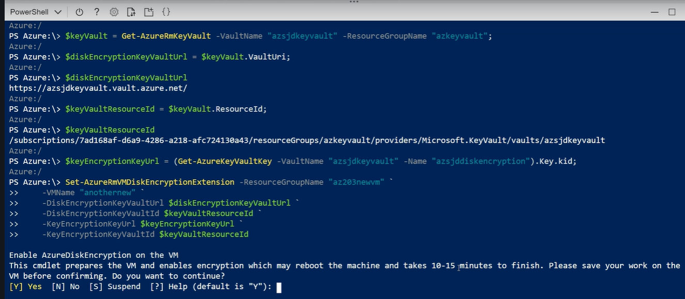

Overall command -

Set-AzureRmVMDiskEncryptionExtension -resourcegroupname kstestrg -vmname ksvmaz203 -diskencryptionkeyvaulturl $keyvaulturi -diskencryptionkeyvaultid $keyvaultresourceid -keyencryptionkeyurl $vaultkey -keyencryptionkeyvaultid $keyvaultresourceid

Under VM--Disks we can see it got enabled

Machine generated alternative text:
OS disk 
anothernew OsDisk 1 2f2b121fef78485cb2aObbb91m 
127 GiB 
Premium SSD 

Azure Batch Service -

* Allows upload batch job and azure manage the schedule.

Machine generated alternative text:
M icrosoft Azure Batch is a fully-managed cloud service that provides so-edulir" ard fw in 
organizations, independent software veryiors and doud service providers. Both r. arri high perforrnance (HPC) 
running workstations and dusters today readily t; in at scale aru] with rx' M-pra•nises req_ired 
application workloads include and video rerdering media transcrxiir-g, Mmte Cario sirm•latims ard softwue test 
executim others all highly parallel corngntationally intensive workloads that cm broken into irxfvidud tasks for execution With Azure 
Batch you can scale from a Whs. up to tens Of Of VMS aryl run the rncst r&nrce-ülterüive 
Learn more 

* Common application workloads include image and video rendering, media transcoding, engineering simulations, Monte Carlo simulations, and software test execution, among others; all highly parallel, computationally intensive workloads that can be broken into individual tasks for execution. With Azure Batch, you can scale from a few VMs, up to tens of thousands of VMs, and run the largest, most resource-intensive workloads

* Azure will manage all the VMs behind and manage their scaling.

Eg: single VM taking 2 days to run a complex simulation , can be deployed to azure batch service with large number of VMs running it and complete entire simulation in 1 hr.

* It needs a batch account which should be unique across the selected region. Also for performance Storage account of this should be same as batch region itself.
* It also ask to select compute pool which can be batch service managed OR we can select from subscription. Basically Batch account has its own subscription as well outside the subscription in which we created it.

Machine generated alternative text:
Dashboard > New ) New Batch account 
New Batch account 
Provide basic Batch account i nfo 
Advance 
Basics 
SpecifB whether to provision compute node in a by Batch 
service. or in the subscription in which you are creating ff.e new Batch account. 
pooL ALLOCATION MO 
Pool allocation mode 
(j Batch service 

OR

Machine generated alternative text:
Basics Advanced Tags 
POOL ALLOCATION MODE 
Pool allocation mode Q) 
Review + create 
O Batch service User 
Batch compute nodes will be deployed as VMS in new resource groups in your subscription. Quota for these VMS will be managed via your 
subscription vCPLl quota. Azure Key vault safeguards encryption keys end application secrets like passwords using keys stored in hardware security 
modules (HSMs). Select a key vault * 
Key vault name 
Please click on "Select a key vault" link above to select a key vault. 
Warning: You must grant Azure Batch access to the selected key vault. We can not automatically granted permission on your 
behalf during Batch account creation process. You need to manually grant permission yourself before you can create an user 
subscription Batch account. 

* Azure Batch Explorer - can be used to explore and see the batch tasks that it is executing and their status and core information.
* If you would like to visualize the samples as they run try [Batch Explorer](https://azure.github.io/BatchExplorer/). Batch Explorer is a client side tool which can assist with creating, debugging and monitoring Azure Batch Applications.
* When we create Batch Account- it has its own optional storage account which can be associated. Also it has its own unique URI and need to be created under resource group/region etc. Batch account has its own keys to access it via SDKs or other tools.

Various keys associated with batch account and its optionally associated storage account are

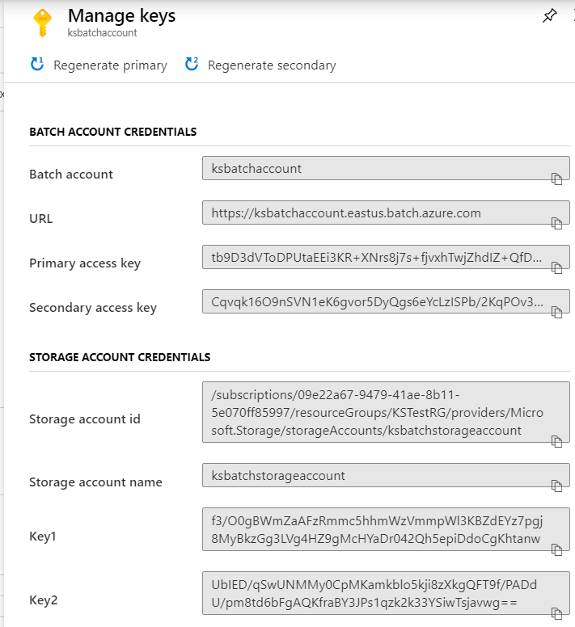

* Code logic to work with Azure batch service -- (code downloaded from azure samples)
  + Need to nuget for batch, storage
  + Create BatchClient using BatchCredentials - which need Batch account name, URL and batch key to connect
  + Add some behavior if needed to batch client like retry count etc for Job operations.
  + Create a Job using Batch Client
  + Set Job settings like Node Pool size/VM size to be sued etc.
  + Call commit on Job object which actually create it in azure.
  + Add Tasks to the job which are of type CloudTasks. (could be others as well)

Useful samples for certification purpose-

<https://github.com/Azure-Samples/batch-dotnet-manage-batch-accounts>

Containers -

* Azure kubernetes Service - kubernetes is open source container technology and was developed by google originally.
* Kubernetes service can be deployed to any cloud platform.
* We create kubernetes cluster where one node is orchestration node and other are worker nodes.
* We can have 1-100 nodes in cluster and this depends on the VM size picked.
* There is a Service Principal setting which basically is the user account that cluster will run under.
* Keep turned of when not needed since it runs multiple nodes under the hood.
* While creating the cluster , we can either use basic network settings where new vnet is created for the cluster nodes OR advanced settings where we can add cluster inside existing vnets and configure subnet and and node address range etc.

Author used yaml template available in azure docs to deploy docker images (available in dockerhub) and used bash (azure cli) to manage kubernetes cluster ie deploy the docker images -

Machine generated alternative text:
az aks get-credentials --resource-group az2Ø3newvm --nane azsjdnewcluster 
Merged "azsjdnewcluster" as current context in /home/scott/ .kube/config 
kubectl get nodes 
STATUS 
aks-agentpooI-32Ø87485-ø Ready 
aks-agentp001-32ø87485-1 Ready 
aks-agentp001-32ø87485-2 Ready 
dir 
ROLES 
agent 
agent 
agent 
azure-vote.yaml clouddrive ignite18 nesh_rp.linux. json 
kubectl apply -f azure-vote.yaml 
. apps/azure-vote-back created 
service/azure-vote-back created 
. apps/azure-vote-front created 
service/azure-vote-front created 
kubectl get nodes 
STATUS 
aks-agentpool -32087485 -e Ready 
aks-agentp001-32ø8748S-1 Ready 
aks-agentp001-32ø87485-2 Ready 
kubectl get service 
TYPE 
azure-vote-back 
Clusterrp 
azure-vote-front LoadBaiancer 
ROLES 
agent 
agent 
agent 
CLUSTER-IP 
xø.ø.109.238 
le.e.134.196 
lø.ø.ø.l 
12m 
12m 
VERSI(N 
VI.11.5 
VI .11.5 
VI .11.5 
VI.11.s 
vi.ll.s 
VI.11.5 
EXTERNAL-IP 
< none> 
cpending> 
< none> 
PORT(S) 
6379/TCP 
Be : 32e74/TCP 
443/TCP 
AGE 
39S 
39S 
kubernetes 
Clusterrp 

Yaml file is present in <https://github.com/Azure-Samples/azure-voting-app-redis>

Upload this yaml through cloud shell itself OR keep it somewhere locally. It contains what docker images to deploy in azure kubernetes service.

\*\*\*With Cloud shell kubeclt command was not found (need to configure or provide full path not sure) so did the same locally after installing azure cli and then aks in cli (az aks install-cli command)

Machine generated alternative text:
PS C: \Program Files\PowerShe11\6> cd C: pc\. azure-kubectl 
Set-Location : A positional parameter cannot be found that accepts argument 
t line:l char:l 
+ cd C: Wsers\acer pc\.azure-kubectl 
' pc\. azure-kubectl' . 
+ Categorylnfo 
. InvalidArgument: ( : ) [Set-Location], ParameterBindingException 
+ FullyQua1ifiedErrorId 
. PositionalParameterNotFound,Microsoft . PowerShe11. Commands . SetLocationCommand 
PS C: \Program Files\PowerShe11\6> cd 
"C: pc\.azure-kubectl" 
PS C: pc\. azure-kubectl> . \kubectl. exe get nodes 
NANE 
STATUS 
ROLES AGE VERSION 
aks -agentp001-77963818-vmssØØØØØØ Ready 
agent 
23m VI. 14.8 
aks -agentpool- 77963818-vmssØØØØØ1 Ready 
agent 
23m VI. 14.8 
aks -agentpool- 77963818-vmssØØØØØ2 Ready 
agent 
23m VI. 14.8 
PS C: pc\.azure-kubectl> .\kubectl. exe apply -f "E:\AZ 203 Azure Developer\aksyaml .yaml" 
deployment . apps/azure-vote-back created 
service/azure-vote-back created 
deployment . apps/azure-vote-front created 
service/azure-vote-front created 
PS C: pc\. azure-kubectl> . \kubectl. exe get nodes 
NANE 
STATUS 
ROLES AGE VERSION 
aks -agentp001-77963818-vmssØØØØØØ Ready 
agent 28m VI. 14.8 
aks -agentpool- 77963818-vmssØØØØØ1 Ready 
agent 28m VI. 14.8 
aks -agentpool- 77963818-vmssØØØØØ2 Ready 
agent 28m VI. 14.8 
PS C: pc\. azure-kubectl> . \kubectl. exe get service 
NANE 
azure -vote -back 
azure -vote -front 
kubernetes 
PS C: 
TYPE 
ClusterIP 
CLUSTER-IP 
10.0.173.114 
LoadBa1ancer Iø.ø. 65 . 61 
ClusterIP 
lø.ø.ø.l 
EXTERNAL-IP 
<none> 
52.149 . 186.247 
<none> 
PORT(S) 
6379/TCP 
W: 32743/TCP 
443/TCP 
AGE 
40s 
39s 
33m 
pc\. azure -kubectl> 

Browsing public front end app IP shows the installed and running app.

Kubernetes Dashboard - it runs locally and follow below -

Kubernets portal in azure doesn’t show much details of the deployed code etc we need to use kubernetes dashboard for this purpose which need azure cli running locally followed by installing kubeclt in azure cli and then using kubernetes service credentials we can connect to kubernetes dashboard and see more details of the cluster.

Machine generated alternative text:
Kubernetes dashboard 
To compkte st«: 
later. in 
to tnvtall the Azure 
tip tip 
W%at is Kub«netes dashbo.Md ? e 
Full opening Kuberne•tes dashboard e 

Kubernetes dashboard when open , it opens up a website running locally ie it runs as a local web server - it will show lot of things like services hosted and running/ what all is deployed / performance counters /

Running all above commands to open kubernetes browser locally (Path variable must be set first for the kubectl command)

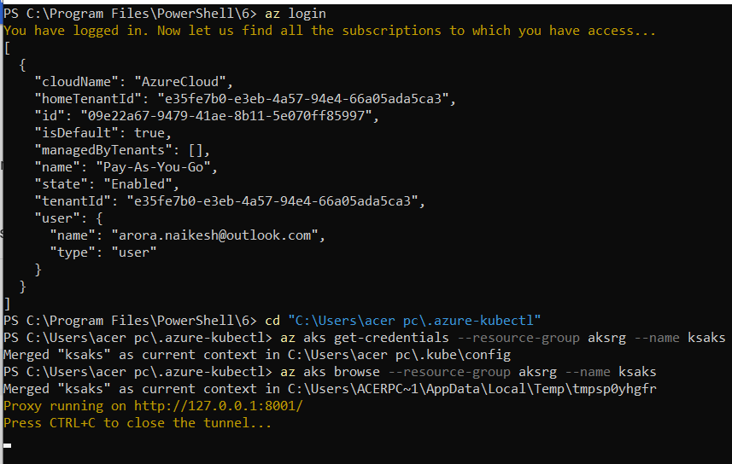

Some issue in dashboard content but it opened fine.

* We can create our own docker images and use them for AKS as well.

Install docker from docker hub- <https://hub.docker.com/editions/community/docker-ce-desktop-windows/>

For windows 10 Home - Docker Toolbox will work --follow instructions and test command docket run hello-world (basically calling an image named hello-world which prints message hello from docker.

<https://github.com/docker/toolbox/releases>

* Once installed - we have docker quickstart terminal -- when ran it creates an oracle virtual box -- this is later used to run our docker containers.
* Once terminal is running - git clone some repo like in this case author used [https://github.com//azure-samples/azure-voting-app-redis.git](https://github.com/azure-samples/azure-voting-app-redis.git)
* Change directly to the cloned repo folder and we have yaml file in here and in this case named docker-compose.yaml containing details of the front and backend images that we need to use for our docker containers.
* Use command docker-compose up -d - this will create front and back end containers deployed to oracle virtual box and we can browse the site using virtual IP and port.
  + To check IP we can use docker-machine IP default command.

IP:8080 will show the running app.

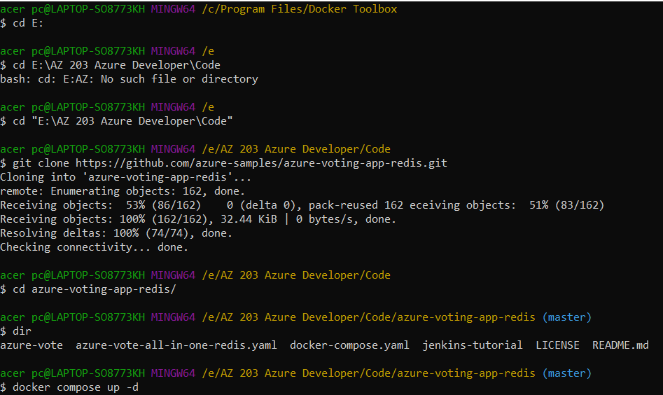

Machine generated alternative text:
cer pc@LAPTOP-S08773KH PlINGW6a /e/AZ 203 Azure Developer/Code/azure-voting-app-redis (master) 
$ docker-compose up -d 
Creating network "azure-voting-app-redis_default" with the default driver 
Pulling azure-vote-back (redis:). 
latest: Pulling from library/redis 

Machine generated alternative text:
c•-er pc@LAPTOP-S08773KH 
$ docker container Is 
/e/AZ 
203 Azure 
CO%AND 
Developer/Code/ azure - voting- app- redis 
CONTAINER ID 
+9276064f7Ød 
6379/tcp 
fa64ea4387df 
IMAGE 
WIES 
redis 
azure -vote -back 
azure -vote -front 
"docker-entrypoint . s?' 
" /entrypoint . sh /stam" 
CREATED 
About a minute 
About a minute 
ago 
ago 
(master) 
STATUS 
Up About a minute 
Up About a minute 
(master) 
PORTS 
ø.ø.ø.ø:6379- 
443/tcp, ø.ø.e 
.0: 808ø->8ø/tcp azure -vote -front 
acer pc@LAPTOP-S08773KH PilNGW6a /e/AZ 
$ docker-machine ip default 
192. 168. 99.100 
203 Azure Developer/Code/azure-voting-app-redis 

Above we have 2 containers for front web server and back redis cache.

To take containers down ie to stop

Machine generated alternative text:
Stopping 
k Stopping 
Removing 
*"Removing 
Removing 
"acer pc@LAPTOP-S08773KH PlINGW6a /e/AZ 203 Azure Developer/Code/azure-voting-app-redis (master) 
$ docker-compose down 
azure -vote -back 
azure -vote -front 
azure -vote -back 
azure -vote -front 
network azure-voting-app-redis_default 
done 
done 
done 
done 

To check images we have in our container

Hello-world is the image which got downloaded when we tested hello-world

Vote-front and redis are the ones used by author from azure-samples github repos.

Nginx is the web server

Machine generated alternative text:
acer pc@LAPTOP-S08773KH 
PilNGW6a /e/AZ 
203 
Azure 
$ docker images 
REPOSITORY 
azure -vote -front 
redis 
tiangolo/uwsgi-nginx-flask 
hello-world 
TAG 
latest 
latest 
python3.6 
latest 
Developer/Code/azure-voting-app-redis (master) 
CREATED 
18 minutes 
9 days ago 
IMAGE ID 
c304fc392c22 
7eed8df88d3b 
eea413ef7853 
fce289e99eb9 
ago 
4 months ago 
14 months ago 
SIZE 
965MB 
98.2MB 
9641B 
1.84kB 

Azure Container Registry - is the service we use to keep our docker container images. There are many SKUs in this registry with basic the simplest with no geo-replication and least price. We can push docker images to this registry service and then later use the same in AKS to run our applications.

Azure container registry basic overview after creation - its URI is XXX.azurecr.io.

Machine generated alternative text:
Resource group (change) 
Location 
Subscription (change) 
Subscription ID 
. aksrg 
East US 
Pay-As-You-Go 
: 09e22a67-9479 
-41 ae 
-8511-5e070ff85997 
Login server 
Creation date 
SKU 
Provisioning state 
: ksaz203registry.azurecr.io 
: 3/7/2020, 11:53 PM GMT+5:30 
. Basic 
. Succeeded 

IMP - to push the images to container registry - we need to login to registry which needs username and password. While creating a registry we can set it to use Admin User and in that case registry name act username and Access Key can be used as password. Access Keys are available for container registries in portal.

Machine generated alternative text:
Home > Container registries 
Container registries 
Default Directory 
-F Add 
Edit columns 
> 
ksaz203registry I Access keys 
ksaz203registry I Access keys 
Container registry 
O Build, Run, Push and Patch 
containers in Azure with ACR Tasks 
Filter by name... 
Name 
ksaz203registry 
Search (Ctrl+/) 
Overview 
Activity log 
Access control (IAM) 
Tags 
Quick start 
Events 
Settings 
Access keys 
Firewalls and virtual network... 
LB Locks 
Export template 
Services 
Repositories 
Registry name 
ksaz203registry 
Login server 
ksaz203registry.azurecr.io 
Admin user O 
Enable 
Disable 
Username 
ksaz203registry 
Name 
password 
password2 
Password 
Ep+mkZGz/2WpPoy5DLREQ5cT6pYNIKij 
LhWXmSaEVbt4bLFsjA5=EFKlWyXt59Z6 
Copy to clipboard 

Or else our registry should have a service principal with correct set of roles like ACR pull/push etc and service principal should come from azure AD. Same then can be used for logging in to kubernetes container registry.

Using Docker Terminal for pushing images -- (can also be done using azure cli)

Docker login registry Login (eg: xxx.azurecr.io)

Username:…

Password: access key password

Done

Docker Push registry Login/image name -- this should push the image to registry.

Machine generated alternative text:
acer pc@L 
4 /c/Program 
F11es/UocKer 
I oolDox 
docker login ksaz2Ø3registry. azurecr.io 
Jsername: ksaz2Ø3registry 
)assword : 
MARNING! Your password will be stored unencrypted in C: pc\.docker\config.json. 
:onfigure a credential helper to remove this warning. See 
Ottps : / /docs . docker.com/engine/reference/commandline/login/#credentials-store 
Login Succeeded 
acer pc@LAPTOP-S08773KH PlINGW6a /c/Program Files/Docker Toolbox 
docker images 
REPOSITORY 
azure -vote -front 
(saz2Ø3registry. azurecr. io/ azure -vote -front 
medis 
tiangolo/uwsgi-nginx-flask 
•ello-world 
TAG 
latest 
latest 
python3.6 
latest 
IMAGE ID 
c304fc392c22 
c304fc392c22 
7eed8df88d3b 
eea413ef7853 
fce289e99eb9 
CREATED 
53 minutes 
53 minutes 
9 days ago 
4 months agl 
14 
months 
acer pc@LAPTOP-S08773KH PlINGW6a /c/Program Files/Docker Toolbox 
docker push ksaz2Ø3registry. azurecr. io/azure-vote-front:vl 
rhe push refers to repository [ksaz2Ø3registry. azurecr. io/azure-vote-front] 
ibcØ7af463e4: 
1Ø917Øaec8Ø9 : 
2e669eØ134f5 : 
558Øa68aØ4e8: 
If73d3284368: 
55e6b89812f3 : 
ze669eØ134f5 : 
Pushed 
Pushing 
Pushing 
Pushed 
Pushed 
Pushing 
Pushing 
104."8/561. 
63 .91MB/141. WB 
55 .12MB/1ØØ. 
63 .38MB/141.8101B 

Post push - images can be seen under Repositories in Container registry.

Code samples on AKS

<https://github.com/Azure-Samples/aks-dotnet-manage-kubernetes-cluster>